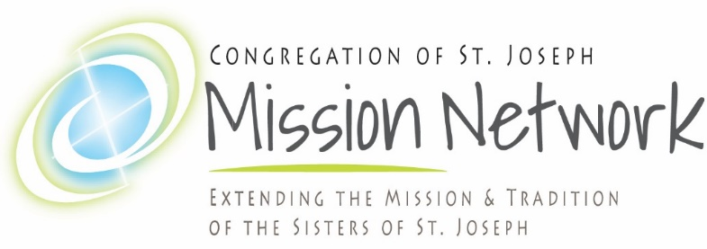

Staff and Faculty Orientation Guide

Welcome to this orientation guide for ministry staff and faculty. This guide will point you to the resources and their locations for the materials that will engage you in this process. Welcome to the CSJ Mission Family!

(all videos are located at CSJMN.org under Staff and Faculty tab, Videos).

View video “Our CSJ Family Story”
- This video introduces you to our humble French roots, where the CSJ mission of unity began. The challenges that called forth this mission through the lives of these women in Le Puy (war, sickness, extreme poverty and more) continue to stimulate this mission in all of us today.
  - Take a few moments to reflect on this question:
    - How does your own personal story mirror your attraction and call to this mission of creating unity?

View Video “Sisterhood”

- The Congregation of St. Joseph was honored to be the first of seven congregations of women religious featured in a 30 minute film produced by Salt+Light, a Canadian Catholic TV network. This video tells the inspiring story of how the Congregation has carried out this mission of unity in the world in recent years.

Staff and Faculty Mission Network Orientation Booklet

- This booklet further outlines the CSJ Mission and tradition, as well as describing more about the Mission Network itself. In the back pocket of the booklet is a copy of the Covenant between your ministry and CSJ Ministries. This Covenant signifies our mutual desire to maintain and grow a strong mission relationship between us for the sake of promoting unity and serving the Dear Neighbor. It outlines our responsibilities to one another and to the mission.

