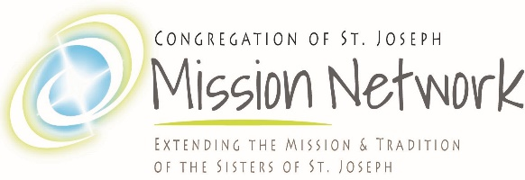
Laudato Si’ Introduction Materials

https://www.youtube.com/watch?v=o3Lz7dmn1eM&t=37s
Laudato Si’ Animation (4:55)

https://www.youtube.com/watch?v=3TReVkRHEV8
What is Integral Ecology

https://www.youtube.com/watch?v=KDFEUvaQydA
CSJ Mission Network Laudato Si’ Presentation (Kathy Sherman, CSJ)

02/2022

