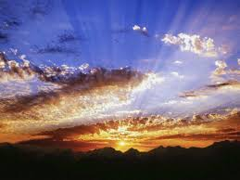
Lent Begins

Song: I Am Light by India Arie

Reading: from A Book of Blessings for the Seasons
by Jan Richardson

I cannot tell you how light comes.

What I know
I cannot tell you
How the light comes
but it does.
That it will.

That it works its way
into the darkest dark
that enfolds you,
though it may seem
long ages in coming
or arrive in a shape
you did not foresee.

is that it is more ancient
then imagining.
That it travels
across an astonishing expanse
to reach us.

That it loves
searching out
what is hidden,
what is lost,
what is forgotten
or in peril
or in pain.
And so
may we this day
turn ourselves toward it.
May we lift our faces
to let it find us.
May we bend our bodies
to follow the arc it makes.

May we open
and open more
and open still
to the blessed light
that comes.

That it has a fondness
for the body,
for finding its way
toward flesh,
for tracing the edges
of form,
for shining forth
through the eye,
the hand,
the heart.

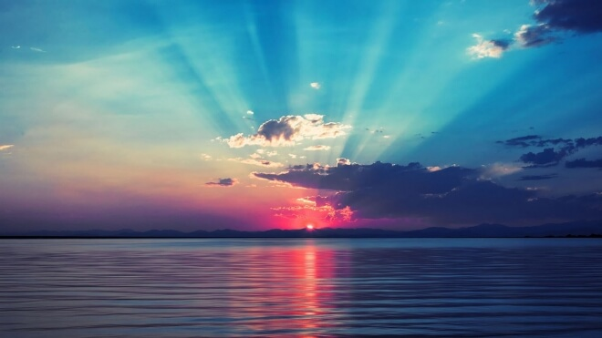

Closing: Prayer of St. Ephrem (4th Century) (together)

Oh God and Redeemer of my life,
Take from me the spirit of
Laziness,
Despair,
Lust for power and control,
Gossip,
Pride.

Give, rather, the Spirit of
Humility,
Patience,
Purity of thought and action,
Self-denial,

With a love for what you love and
A burden for what burdens you.

Help me to see my own errors and wounding arrows,
And to forgive and not judge those of my sisters and brothers.

For you alone are just and holy,
Now and forever.

Amen.
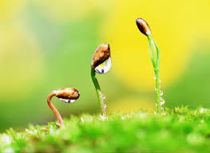

In the light of all that is going on
in your life and/or in our world, --
what does this Lenten poem offer you?

How can we bring Light into each other. our neighbor and our community through this ministry?

