As we work together, we urge you
not to accept the grace of God in vain.
2 Cor 6:1

A Blessing for Ash Wednesday
by Jan Richardson

All those days
you felt like dust,
like dirt,
as if all you had to do
was turn your face
toward the wind
and be scattered
to the four corners

or swept away
by the smallest breath
as insubstantial--
So let us be marked
not for sorrow.
And let us be marked
not for shame.
Let us be marked
not for false humility
or for thinking
we are less than we are

but for claiming
what God can do
within the dust,
within the stuff
of which the world
is made,

and the stars that blaze
in our bones,
and the galaxies that spiral
inside the smudge
we bear.
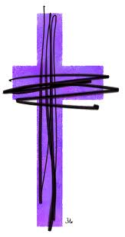

What blessing do I ask for this time of Lent ?

What is the grace that that lives
within my deepest self
that God is stirring into new life for the sake of unity?

Did you not know
what the Holy One
can do with dust?

This is the day
we freely say
we are scorched.

This is the hour
we are marked
by what has made it
through the burning.

This is the moment
we ask for the blessing
that lives within
the ancient ashes,
that makes its home
inside the soil of
this sacred earth.

