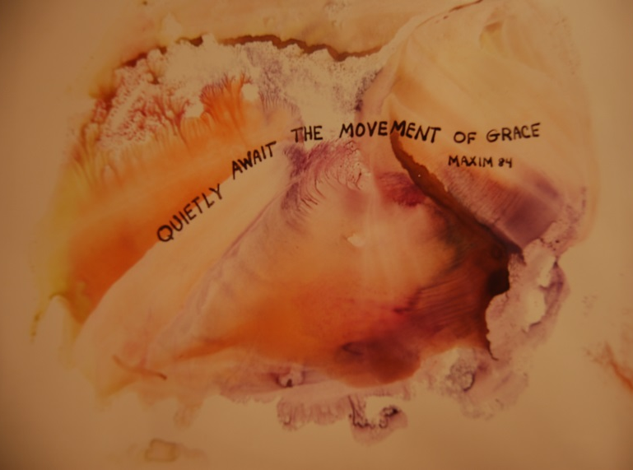
Prayer for Inclusive Love

Gathering around the table is a long tradition for Sisters of St. Joseph, Associates, partners in ministry, and friends. Since our first six Sisters ministered in LePuy, we have continued to gather around the table to share our lives and our stories since 1650. Hopefully, the stories will continue to challenge and call us forth to deeper passion and dedication to every neighbor, without distinction.

Reading:
St. Paul to the Ephesians 2:13-13, 18-22 translation The Message

Sisters and brothers,

It was only yesterday that you outsiders to God’s ways had no idea of any of this, didn’t know the first thing about the way God works, hadn’t the faintest idea of Christ. You knew nothing of that rich history of God’s covenants and promises in Israel, hadn’t a clue about what God was doing in the world at large.

The Cross got us to embrace, and that was the end of the hostility. Christ came and preached peace to you outsiders and peace to us insiders. He treated us as equals, and so made us equals. Through him we both share the same Spirit and have equal access to the Creator.

That’s plain enough, isn’t it? We’re no longer wandering exiles. This kingdom of faith is now our home country. We’re no longer strangers or outsiders. We belong here. God is building a home, using us all—irrespective of how we got here—in what is being built. He used the apostles and prophets for the foundation. Now God’s using you, fitting you in brick by brick, stone by stone, with Christ Jesus as the cornerstone that holds all the parts together. We see it taking shape day after day—a holy temple built by God, all of us built into it, a temple in which God is quite at home in the diversity that is us.

Sharing
What story or experience in your life relates to this reading?
What has been your experience in relating with other cultures, races, etc.?

Closing thoughts
As we go forth, let us listen to a telegram John Pierre Medaille might have written to Sisters of St. Joseph, partners in mission, associates and friends around the world:

Urgent!
Reawaken desire to live and serve every kind of neighbor, STOP
Dare to face today’s realities-STOP
opportunities and dangers exist-STOP
Dare to risk growth and old age fruits produced in Love-STOP
Imperative to promote unity among all people and with God-STOP
We are all One. NEVER STOP

